HW5_Simulation Section (EE576)

Design and Simulation Problem

Instructor: Dr. Subhanshu Gupta

By: Mohammad Chahardori

ID:11632753

November 2018

Simulation Problem:
Convert the design in HW4 to a differential amplifier with single-ended output.
Consider load resistor RD=500Ω, the capacitor Cload of 2pF, and Vdd=1.3V.
You are to use an 130nm CMOS process. The design goals for this circuit are as follows:
- Low frequency differential-in to single-ended output ac voltage gain > 30dB
(ie. Gain = Vout/(Vin+-Vin-) )
- Maximum output swing > 0.3Vpk-pk-se
- Unity gain bandwidth > 500MHz
What you need to turn in for this problem are:
- A. (20 pts) Hand calculation results including the values of DC bias voltage and current, transistor size, small-signal gain, output resistance, and maximum output swing.
- B. (20 pts) Cadence simulation results including a plot of small-signal gain and phase, and information showing DC conditions of the MOSFET.

Report: Attach schematics with DC operating points, AC gain and phase, transient simulation showing results at the bias points with the output and input swings. You have to ensure that none of these transistors go out of saturation at the maximum or the minimum input voltages. Vbias, Vb2, and Vb3 are implemented using VDC symbol in analogLib library in cadence.
Answer to the Simulation Problem:
In fig.1 the basic schematic of the circuit has been shown.

Fig.1. Schematic of the circuit
According to the required specification of the amplifier, the minimum low frequency differential gain of the amplifier is 30 dB which is about 32. To satisfy this gain after final circuit design, we consider 25% margin for this gain and assume the overall gain is 40. On the other hand, according to the differential half circuit structure (Right half of the circuit in fig.1) and considering the common sources of M1 and M2 is virtual ground in differential mode because it is placed on symmetry line, the amplifier differential gain in low frequency is:
(1)

The other small signal parameters that we must satisfy is the unity gain band width ( ) of the amplifier in deferential mode. According to the right half circuit of fig.1 in differential mode, the amplifier circuit shows two poles at the Drain of and output node (). The values of these two poles are as bellow:
(2)

To determine the dominant pole, we have to consider the resistance and the capacitance which make these two poles. Since, the output capacitance and resistance are much larger than the capacitance seen from the drain of M1 or M2, it seems that the dominant pole would be placed at the output node.
Now, to have the required , we must make sure that our assumption about dominant pole is correct. In that case, we need to put the pole of node A (drain of M1,2) into higher frequency than . In this case, we have:
(3)
It should be note that since the first pole is located at output node the capacitor Cgd9 should not be calculated from miller effect. In fact, According to the values of parasitic capacitors in 0.13um CMOS technology for usual sizing of M1,2 and M4,9 the parasitic capacitors would be less than 1.5PF which satisfy the above equation. But it is necessary to check the parasitic capacitors after determination of M1,2 and M4,9 sizing.
Considering the two poles and DC gain of the amplifier we have:
(4)
Considering the value of gain 4 in the first stage () based on equation (1), for the we have:
(5)

We have considered to make sure that is achievable after simulation of the circuit.
The third specification of the amplifier which should be satisfied by the designers is the swing at the amplifier output. According to the problem the amplifier should have 0.3V peak to peak voltage swing at the single ended output. That means the output voltage should be able to vary around its bias voltage without forcing any of the M9 and M6 transistors in the half circuit to enter the linear or cut-off regions. So it is important to set properly the output DC bias voltage. To find the proper DC bias voltage, first we should know the output voltage range that keeps all transistors in saturation region. This range can be calculated by determination of saturation region for each transistor as bellow:
(6)
The maximum voltage level is limited by M9 as follow:
(7)
This means that the maximum available output swing can be large as:
(8)
This amount of swing can easily cover the required 0.3V required swing at the output.
On the other hand, the DC output voltage is equal to:

(9)
The above equations shows that since the overdrive voltage of M5 and M6 are equal, so regardless of any chosen value for the amplifier would have negative swing around . So, it seems that considering gives us easily the required output voltage swing.
Now, using equation (1) to (9) and considering the parameters of the transistors which have been extracted from simulation of an NMOS transistor in 0.13um CMOS technology and are shown in Table.1 we would be able to determine the sizing of transistors and bias voltages of the circuit to satisfy all the requirements of the circuit.

Table.1. Transistor Parameters
Parameter | Value
 | 350
 | 200
 | 0.38 V
 | 0.42 V
 | 0.5
 | 0.45

To start calculation of the transistors’ W and L based on the achieved values for gm we can consider a reasonable value for overdrive voltage of M1,2 and M4,9 and M3, M5,6 transistors. We start with 0.1V to 0.2 V voltage overdrive for M1,2 and M3, M5,6 because it is far from the subthreshold region, also it is not too large and as a result helps us to achieve higher gm with constant amount of current. Overdrive of M4,9 is a function of DC voltage of the first stage and should be calculated after deriving the bias current of the first stage.
So, we have:
and (10)
Now based on the value of which is obtained from equation (1) we have:
(11)
As we see from (11) the value of bias current of M1,2 is . Consequently, the value of DC bias voltage of the first stage is:
(12)

Therefore, for the overdrive voltage of transistors M4 and M9 we have:

(13)
and based on the calculated from equation (5) we have:
(14)
From (11) and (14) we achieved not only the transistor sizing of M1,2 and M4,9 but also we derived the values of bias currents of first and second stage as and Now according to the overdrive voltage and bias current of transistors M3 and M5,6 we can calculate their sizing.
(15)

Now based on equations (9) and (10) the output bias voltage would be equal to:
(16)

Now it is time to calculate the W and L of M3. Due to differential structure of the circuit in fig.1 the bias current of M3 is equal to the summation of . Considering 0.2V for we have:
(17)

We should remember that, since we don’t have tight limitation on the swing in the first stage, we can consider higher value for to reduce . In fact, the DC value of the drain voltage of M2 (the output of the first stage) is 0.85V based on (12). So, even with single ended swing at this point we would have 0.65V headroom to provide the required DC bias voltage for of M2 and M3 to keep them in saturation region. Since we considered before, we can allocate up to 0.55V to . For example, we can set at 0.35V. With the ratio would get smaller which leads to smaller M3 transistor area and less parasitic too. In this case we have:

(18)

As it is seen in equation (18), this 150mV change in decreases the about 4 times. Now we can calculate the based on the and when we consider as bellow:
(19)

The last step is to derive the appropriate values for the bias voltages of the circuit based on bias currents, overdrive voltage of transistors and the transistors’ parameters.
The required input DC voltage at the gate of M3 to set the current of M1 at the required is:
(20)
The other DC voltage which we should have calculate is input DC voltage which is gate bias voltage of M1 and M2. With the mentionedfor M1 and M2 to keep both M2 and M3 in saturation region we would have:
(21)

Now based on calculated values for transistors W, L and bias voltages of the circuit we can design and simulate the circuit in the Cadence software.

Simulation:
Based on the values achieved through calculation the circuit has been designed. Some modification in size and bias voltage has been done to achieve the required gm, gain and other specs of the circuit. In table 2 the final values for transistor sizing and bias voltage are shown.
Table.2. Real sizing after simulation
Parameter | Value
Current Consumption | 2
Vin (DC) | 950 mV
Vbias (M3) | 770mV
 | 900
 | 280
 | 83
 | 90

The circuit with DC operating points has been shown in fig.2. The simulation results for AC response and transient response are shown in fig.3 and fig.4 respectively. As it is seen, all the requirements of the circuit are in acceptable range.

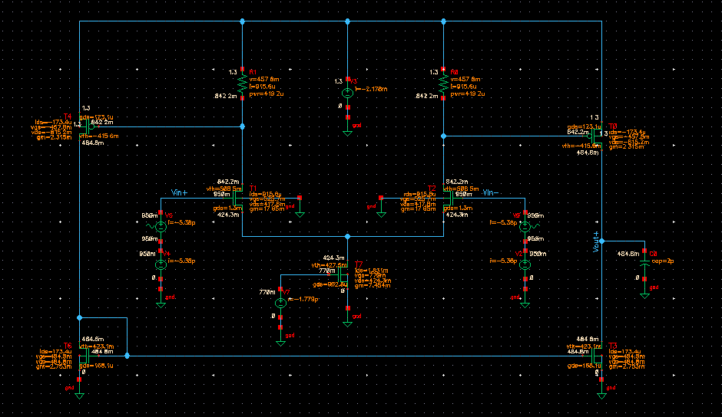
Fig.2. Schematic of the designed circuit with operating points

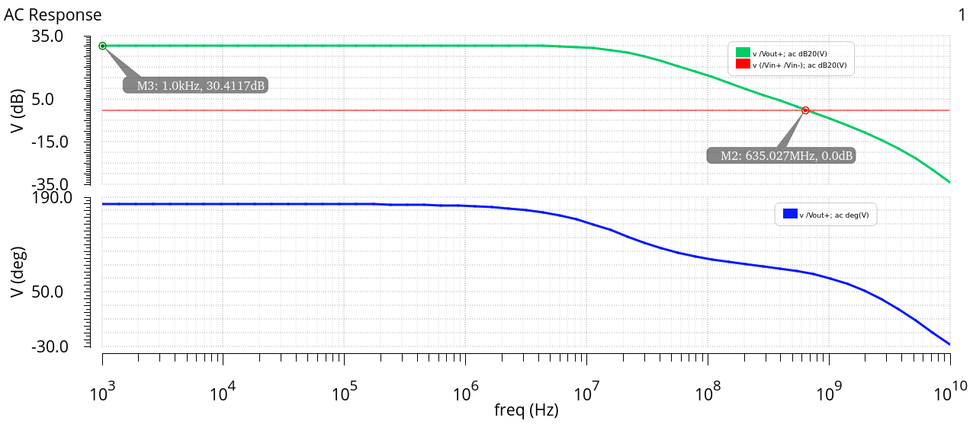

Fig.3. AC Response

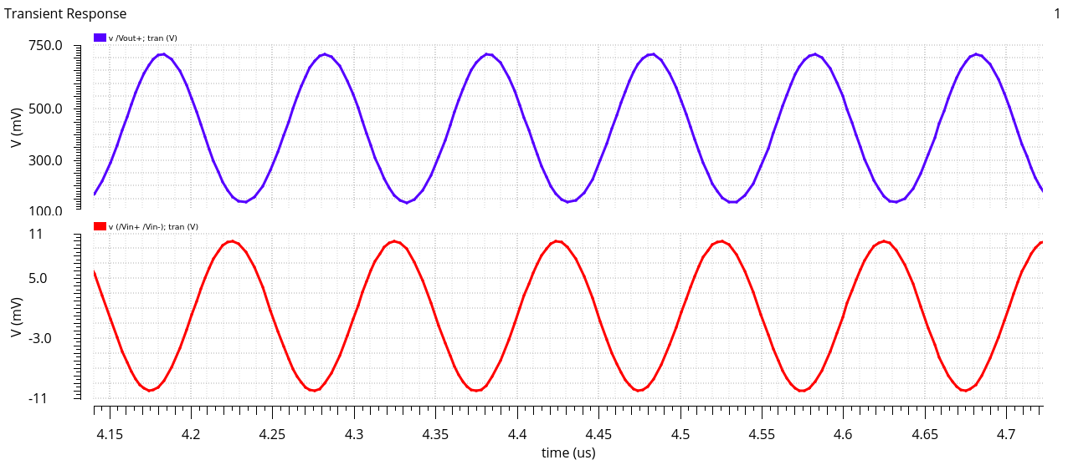
Fig.4. Transient Response. Output voltage (blue) and input differential voltage (red)

